TELCO CUSTOMER CHURN ANALYSIS

Service Analysis, Financial Impact & Retention Strategy

7,043 Customers Analyzed | 26.5% Churn Rate | $139.1K/mo Revenue Lost

Table of Contents
1. Project Overview
2. The Brief: What Stakeholders Asked
3. Data & Tools
4. Executive Summary
5. Customer Behaviour — Who's Leaving, and Why It's Predictable
6. Service Analysis — What Keeps Customers Loyal
7. Financial Impact — What Churn Is Actually Costing Us
8. Business Insight — Is It Price, or Is It Us?
9. Recommendations
10. Limitations & Notes

1. Project Overview
Customer churn is the single biggest threat to recurring revenue in a subscription business. This project analyzes 7,043 customers of a telecom provider to answer a concrete question: where is churn concentrated, what is it costing the business, and what should be done about it, in that order.
Rather than exploring every possible cut of the data, this analysis was scoped the way a real analytics engagement would be: around specific questions from specific stakeholders. That scoping decision, what to include and, just as importantly, what to leave out is part of the deliverable, not an afterthought.

2. The Brief: What Stakeholders Asked

Stakeholder | Question | What It Maps To
CFO | “Where is the money actually going?” | Quantify revenue and lifetime value lost to churn
VP, Retention | “Who's leaving, and who's next?” | Profile churn by contract and payment behaviour
Head of Product | “Which services should we push harder?” | Prove which add-ons reduce churn risk
CX Lead | “Is it price, or is it us?” | Separate price-driven churn from service-driven churn

Demographic segmentation (gender, partner/dependents status) was deliberately not built out as a standalone section as none of the above stakeholders asked for it, and the signal there is weak. The one exception worth noting: senior citizens churn at 41.7% vs. 23.6% for everyone else was flagged here, but not treated as a full section, since no stakeholder persona required it.

3. Data & Tools
- Dataset: IBM Telco Customer Churn dataset (7,043 customers, 21+ attributes) — telecom_churn_data.csv
- Dashboard: Power BI (.pbix) — 5-table star schema (Telco_Fact, Telco_customer_dim, Telco_Service_dim, Telco_Contract_dim, Telco_churn_reason_dim)
- Presentation: 11-slide stakeholder deck (Customer_Churn_Analysis.pptx), built for a 10-minute delivery window
- Data Modeling: The source data arrived as a single flat table; Python (pandas) was used to normalize it into a 5-table relational structure (star schema) to support proper data modeling and relationships in Power BI.

Key fields used: Contract, Payment Method, Internet Service, Online Security, Tech Support, Online Backup, Device Protection, Tenure Group, Monthly Charges, Total Charges, CLTV (Customer Lifetime Value), Churn Value, Grouped Churn Reason.

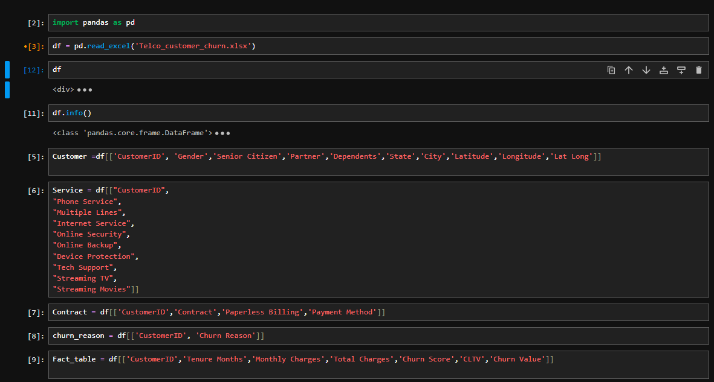
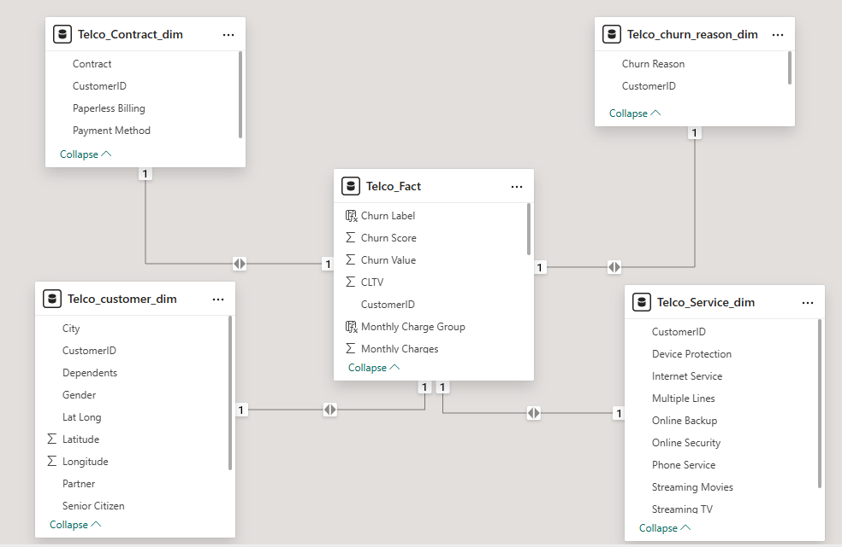

4. Executive Summary
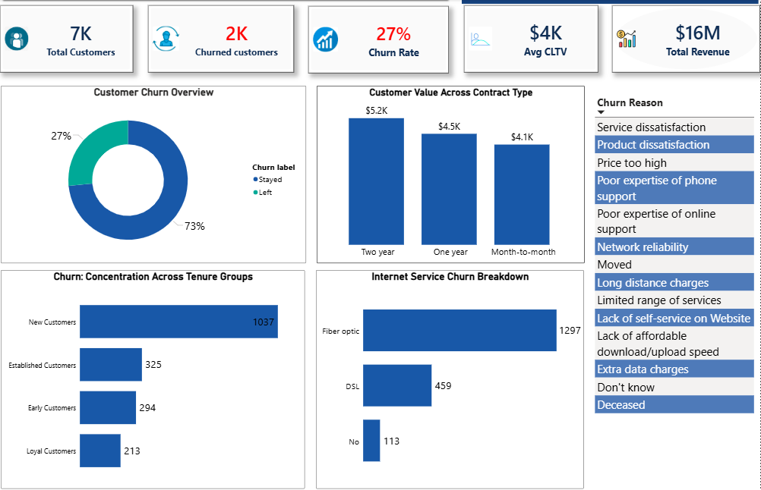

THE STORY IN ONE LINE
1 in 4 customers has churned, concentrated almost entirely in month-to-month, fiber-optic, electronic-check customers. This segment alone drives roughly half of monthly revenue lost, making it the single highest leverage target for retention investment.

5. Customer Behaviour — Who's Leaving, and Why It's Predictable

Contract type is the strongest churn signal in the data. Month-to-month customers churn at 42.7% over 15x the rate of two-year contract customers (2.8%) and account for 88.55% of every customer who has left.

Payment method tells a similar story. Electronic Check users churn at 45.3%, roughly 3x the rate of automatic payment methods (Bank Transfer: 16.7%, Credit Card: 15.2%). Electronic Check alone accounts for 57.3% of all churned customers, more than the other three payment methods combined.

INSIGHT
Both signals are visible before a customer leaves, not just explained after the fact, meaning, at-risk customers can be flagged and engaged proactively rather than analyzed retrospectively.

RECOMMENDATION
Build a simple risk flag for month-to-month + manual payment customers and route them into proactive retention outreach (contract-upgrade offers and autopay incentives) before they reach cancellation.

6. Service Analysis — What Keeps Customers Loyal
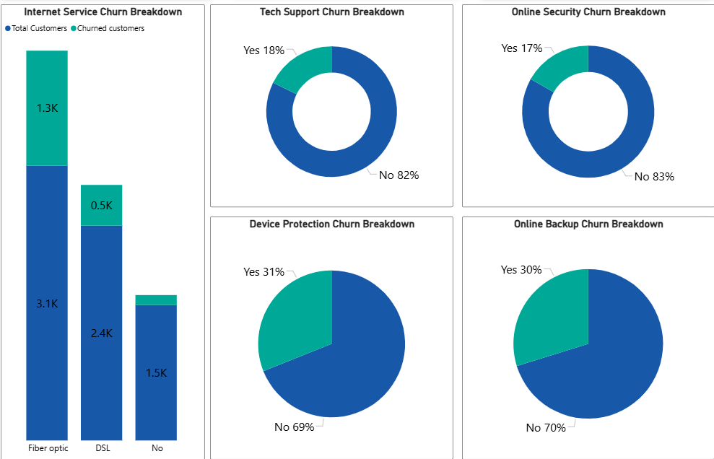

Internet Service type is also a major factor: Fiber optic customers churn at 41.9% more than double DSL customers (19.0%) despite fiber being the company's premium offering. Fiber customers make up 69.4% of all churned customers.

RECOMMENDATION
Bundle Online Security, Tech Support, and Backup as a default “Protection Package” for fiber customers rather than an ad on service.

7. Financial Impact — What Churn Is Actually Costing Us
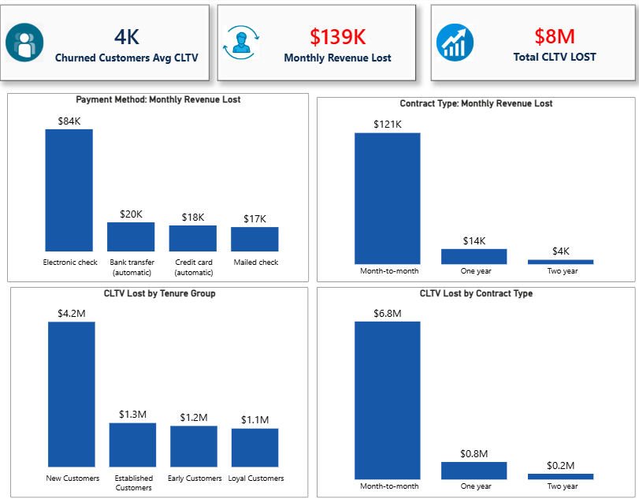

Across all four cuts, financial exposure concentrates in the same places:
- Month-to-month contracts drive 87% of both monthly revenue lost ($120.8K) and CLTV lost ($6.76M)
- Electronic Check accounts for 61% of monthly revenue lost ($84.3K)
- New Customers alone represent $4.19M which accounts for over half of all CLTV lost despite being one of four tenure groups

Churn isn't spread evenly. It's concentrated in short-tenure, low-commitment customers, and importantly, churned customers were not low value: their average CLTV ($4,149) sits close to retained customers' ($4,491). This is a loss of volume and commitment, not a loss of low-worth customers.

RECOMMENDATION
Prioritize retention spend on new, month-to-month, Electronic Check customers as this single overlapping group carries the majority of both the ongoing monthly bleed and the long-term value at stake.

8. Business Insight — Is It Price, or Is It Us?

Pricing is the smallest stated driver of churn. Competitive pressure and service/support experience combined account for over half of all stated churn reasons. This reframes the retention conversation: this is more of a service and competitive positioning problem than a pricing problem.

RECOMMENDATION
Don't default to discounting as the primary retention lever. invest in service/support quality and competitive differentiation (speed, reliability, features) alongside any pricing response.

9. Recommendations
Three moves, prioritized by leverage:

1. Convert month-to-month customers. Discounted annual/2-year plans and loyalty perks to reduce the segment driving 88% of churn.
2. Migrate customers to autopay. Incentivize bank transfer / credit card autopay to cut churn risk by ~3x vs. Electronic Check.
3. Bundle protection services. Default Online Security, Tech Support, and Backup into fiber plans to roughly halve churn risk.

10. Limitations & Notes

- CLTV is a modeled/predicted value, not a historical sum of amounts paid. it should be read as a directional, relative comparison between segments rather than a number to bank on with full precision.
- All customers in this dataset are based in a single state (California), so no state-level geographic segmentation was possible; city-level variation was not analyzed as it fell outside the stakeholder brief.
- Demographic segmentation (gender, partner/dependents) was scoped out deliberately, as no stakeholder question required it and the signal was weak, with the exception of Senior Citizen status noted above.
- This is a capstone/practice project built on a public, well-known dataset (commonly used for churn-modeling exercises). Findings are illustrative of the analytical approach, not a live business engagement.

